System Optimization Basics - SysOpt is an entire RHCA 4-day class

The /proc filesystem
Keep in mind that most of the system monitoring utilities are just reading /proc files
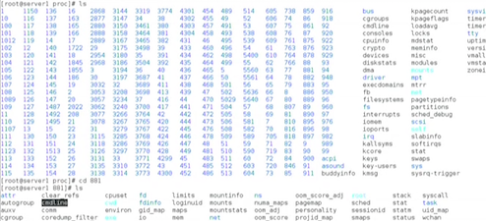
Did you remember that /proc kept a directory for every running process?
Good catch: "cat /proc/filesystems" and it didn't list vfat. Run "modprobe vfat" and try again and there it is! It wasn't loaded.
/proc/sys has filesystem types
/proc/net has ipv4, ipv6, netfilter directories of goodies
/proc/sys/vm/swappiness file has a value for how willing the system is to use swap

cat /proc/net/ipv4/ip_forward contains 0 which means it isn't routing
If you reboot, this stuff is gone. Make it permanent with /etc/sysctl.conf /etc/sysctl.d/

sysctl is specifically for /proc/sys
sysctl -a ---lists all of the system tunables

There are arguments to change the /proc filesystem and the /etc/sysctl.conf at the same time (sysctl -w and -p)
Vugt says it's better to be careful by writing to /proc/sys with echo, so if you make a mistake, you can reboot and start over- if you write them immediately to the conf files and you make a mistake, then you are stuck with fixing it
Echo to /proc/sys first to test and then commit to /etc/sysctl.conf when you are sure. ( I would do this manually with VIM anyway)
part33 and 34.mp4 --good video --review
Remember from my own work you don't have to restart to test things- systemctl restart sysctl

sysctl -a | grep icmp
(lists values)
echo 1 > /proc/sys/net/ipv4/icmp_echo_ignore_all
---temporarily sets. test with pings out, no replies. It worked
vim /etc/sysctl.conf - and put it in there

Exercise 4 - make sure ping is enabled, set swappiness to 50, and apply permanently

